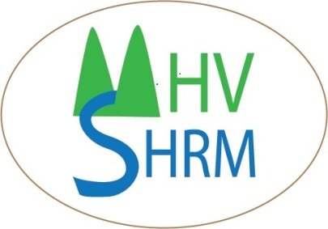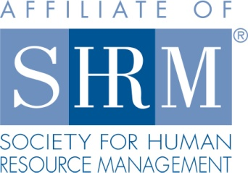
Mid-Hudson Valley
Society for Human Resource Management

January 23, 2014 Chapter Meeting
Collaborative Law
SPEAKER: Marc O. Sheridan
Location: Harness Racing Museum
240 Main Street
Goshen, NY 12549
845-294-6330
DATE & TIME: Thursday, January 23, 2014
8:15 - 8:45 am Registration, Breakfast
8:45 – 9:15 Announcements & Introductions
9:15- 10:30 am Program
COST: $15 Chapter Member; $25 Non-Chapter Member; $7 Student
Please reserve your spot by contacting Beth Schick at info@mhvshrm.org.

PROGRAM DESCRIPTION: Collaborative law is an efficient employment litigation alternative. Collaborative Law offers employers and employees a private, client-centered process that encourages good-faith, face-to-face negotiations of employment disputes. Workshop participants will observe and learn how Collaborative Law facilitates settlement through structured interest-based negotiations relying on reason rather than emotion. Through lecture and video excerpts, Mr. Sheridan will demonstrate how the Collaborative process helps parties identify individual interests, address mutual concerns, and develop workable practical solutions for employment disputes.

ABOUT THE SPEAKER: MARC O. SHERIDAN, Esq., is a mediator with the Southern District of New York’s mediation panel as an employment mediator, the New York Supreme Court, Commercial Division, and the Westchester County Human Rights Commission. He is a member of the New York State Bar Association ADR Section and Collaborative Practice Committee, the American Bar Association Dispute Resolution Section, the International Academy of Collaborative Professionals (IACP), and the Global Collaborative Law Council. Mr. Sheridan frequently writes, lectures, and is consulted on employment law developments and dispute resolution techniques for both human resources professionals and business owners in the New York City metropolitan area. In 2009, Mr. Sheridan was interviewed on CBS Internet radio on the benefits of Collaborative Law in the business and employment context. In October 2011, Mr. Sheridan lectured on utilizing ADR techniques in employment and business disputes for the New York State Bar Association, Dispute Resolution Section, and the IACP at its annual forum in San Francisco. Mr. Sheridan is also founder of the New York Civil Collaborative Group, which in 2012 completed a CLE video webinar for lawyers through the International Institute of Conflict Prevention and Resolution on using Collaborative Law in employment disputes. In May 2013, Mr. Sheridan was interviewed in Bloomberg BNA’s Human Resource Report and presented to the Dallas Bar Association’s Collaborative Law and Labor and Employment Law Sections on applying Collaborative Law to workplace disputes.

In addition to his mediation and collaborative law experience, Mr. Sheridan has represented clients for more than a decade concerning employment discrimination claims, restrictive covenants, deferred compensation plans, reductions in force, negotiation of severance agreements, and executive compensation issues. He has litigated claims under the ADEA, ADA, Title VII, the New York State Human Rights Law, and the New York City Administrative Code in state and federal trial and appellate courts. Mr. Sheridan regularly appears in FINRA and AAA arbitrations on behalf of securities industry professionals regarding unpaid bonuses, promissory notes, and contractual disputes. Mr. Sheridan also has extensive experience representing corporate clients on risk transfer and liability issues involving commercial leases and contracts.

Mid-Hudson Valley
Society for Human Resource Management
February 27, 2014 Chapter Meeting
New Obligations Imposed on NYS Employers in 2014
SPEAKER: Devora Lindeman
Location: Harness Racing Museum
240 Main Street
Goshen, NY 12549
845-294-6330
DATE & TIME: Thursday, January 23, 2014
8:15 - 8:45 am Registration, Breakfast
8:45 – 9:15 Announcements & Introductions
9:15- 10:30 am Program
COST: $15 Chapter Member; $25 Non-Chapter Member; $7 Student
Please reserve your spot by contacting Beth Schick at info@mhvshrm.org.
PROGRAM DESCRIPTION: This program will cover new obligations imposed on NY employers in 2014, as well as discuss pending legislation and trends that HR Managers should be aware of. It will cover such topics as:
• The Overturning of the Defense Against Marriage Act (DOMA) and how that affects employers’ FMLA obligations;
• New York’s new law regarding unemployment insurance and how that affects employers responses to unemployment forms;
• The Affordable Care Act (ObamaCare) and what employers need to do in 2015;
• New York’s minimum wage increase
• New York’s wage theft prevention act (it is not going away)
• New York’s new partnership with the U.S. DOL and what that means for the use of Independent Contractors;
• Use of e-cigarettes in the workplace – should your smoking policies prohibit them?
• Pending legislation or actions that can affect employers:
o NY Law prohibiting bullying;
o NY Law protecting discrimination against unpaid interns
o NY Law prohibiting using credit reports in employment decisions.
o New I-9 Form
o Mandatory E-verify
ABOUT THE SPEAKER: Devora L. Lindeman is a partner with the management-side employment law firm of Greenwald Doherty, LLP. Although she is based in Rockland County, she represents business and non-profit clients throughout New York State in all aspects of labor and employment law. Devora frequently lectures to employer associations to educate employers regarding their compliance obligations to prevent employee problems before they start. She both consults with clients with regard to the compliance aspects of the various labor and employment laws, and represents business clients in federal and state courts and agencies, defending them against such claims as discrimination, harassment, failure to accommodate disabilities, wage and hour violations, FMLA violations and much more. Devora received her undergraduate degree from Sarah Lawrence College, and was graduated from the Rutgers School of Law in Newark with highest honors.

