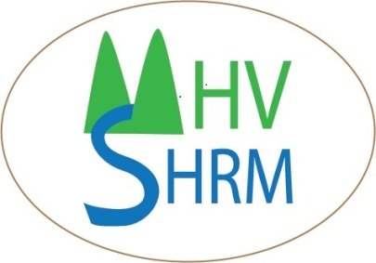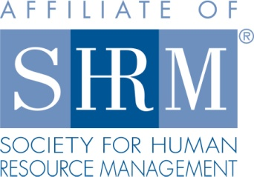
Mid-Hudson Valley
Society for Human Resource Management

February 27, 2014 Chapter Meeting
New Obligations Imposed on NYS Employers in 2014
SPEAKER: Devora Lindeman
Location: Harness Racing Museum
240 Main Street
Goshen, NY 12549
845-294-6330
DATE & TIME: Thursday, January 23, 2014
8:15 - 8:45 am Registration, Breakfast
8:45 – 9:15 Announcements & Introductions
9:15- 10:30 am Program
COST: $15 Chapter Member; $25 Non-Chapter Member; $7 Student
Please reserve your spot by contacting Beth Schick at info@mhvshrm.org.

PROGRAM DESCRIPTION: This program will cover new obligations imposed on NY employers in 2014, as well as discuss pending legislation and trends that HR Managers should be aware of.
It will cover such topics as:

* The Overturning of the Defense Against Marriage Act (DOMA) and how that affects employers’ FMLA
obligations;
* New York’s new law regarding unemployment insurance and how that affects employer’s responses to
unemployment forms;
* The Affordable Care Act (Obama Care) and what employers need to do in 2015;
* New York’s minimum wage increase
* New York’s wage theft prevention act (it is not going away)
* New York’s new partnership with the U.S. DOL and what that means for the use of Independent Contractors;
* Use of e-cigarettes in the workplace – should your smoking policies prohibit them?
* Pending legislation or actions that can affect employers:

* NY Law prohibiting bullying;
* NY Law protecting discrimination against unpaid interns
* NY Law prohibiting using credit reports in employment decisions.
* New I-9 Form
* Mandatory E-verify

ABOUT THE SPEAKER: Devora L. Lindeman is a partner with the management-side employment law firm of Greenwald Doherty, LLP. Although she is based in Rockland County, she represents business and non-profit clients throughout New York State in all aspects of labor and employment law. Devora frequently lectures to employer associations to educate employers regarding their compliance obligations to prevent employee problems before they start. She both consults with clients with regard to the compliance aspects of the various labor and employment laws, and represents business clients in federal and state courts and agencies, defending them against such claims as discrimination, harassment, failure to accommodate disabilities, wage and hour violations, FMLA violations and much more. Devora received her undergraduate degree from Sarah Lawrence College, and was graduated from the Rutgers School of Law in Newark with highest honors.

Mid-Hudson Valley
Society for Human Resource Management

March 27, 2014 Chapter Meeting
Dealing with Workplace Bullying
SPEAKER: Bill Colagrande

Location: Harness Racing Museum
240 Main Street
Goshen, NY 12549
845-294-6330

DATE & TIME: Thursday, March 27, 2014
8:15 - 8:45 am Registration, Breakfast
8:45 – 9:15 Announcements & Introductions
9:15- 10:30 am Program

COST: $15 Chapter Member; $25 Non-Chapter Member; $7 Student

Please reserve your spot by contacting Beth Schick at info@mhvshrm.org.

PROGRAM DESCRIPTION: Workplace bullying affects more than half of the workplace population. It is a consistent, repeated behavior that can take the form of teasing, exclusion, missing or being late for appointments or meetings, undue criticism, failure to return calls or e-mails, violation of personal and professional boundaries, gossip and unfair treatment. Nearly three quarters of workplace bullying occurs from a supervisor toward his/her supervisee.
Unaddressed workplace bullying can lead to serious emotional and physical health problems such as depression, loss of appetite, backaches, ulcers, drug and alcohol abuse and more. It will have a negative impact on morale, productivity and efficiency on the job.

In this presentation we will learn how to:
- Identify and recognize instances of workplace bullying
- Stand up for yourself in an appropriate manner
- Confront the bullying behavior of co-workers
- Recognize how to approach the authorities in your company
- Respond when the Boss is the bully
- Deal with the reactions of your co-workers
ABOUT THE SPEAKER: Bill Colagrande, an author, psychotherapist and licensed mental health counselor, opened the Institute for Human Development in uptown Kingston in 2004. He earned a BA in Psychology from Seton Hall University and a Master’s degree in Counseling from Miami University.

Aside from direct clinical services to couples and individuals, Bill has served as a business consultant to such local companies as Ulster Savings Bank, Johnson Ford, the Ulster County Social Services Department and the Golden Hill Nursing Facility.

He has developed a variety of training materials that help keep your valued employees healthy and productive. These titles include How to Get Along with Almost Anybody at the Workplace, Dealing with Workplace Bullying, How to Be a Star Employee and How to Succeed in Business by Really Trying.

Bill, an avid fisherman and active Rotarian, lives in Phoenicia, NY with his lovely wife Margit.

