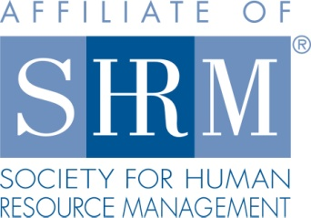
Mid-Hudson Valley
Society for Human Resource Management

March 27, 2014 Chapter Meeting
Dealing with Workplace Bullying
SPEAKER: Bill Colagrande

Location: Harness Racing Museum
240 Main Street
Goshen, NY 12549
845-294-6330

DATE & TIME: Thursday, March 27, 2014
8:15 - 8:45 am Registration, Breakfast
8:45 – 9:15 Announcements & Introductions
9:15- 10:30 am Program

COST: $15 Chapter Member; $25 Non-Chapter Member; $7 Student

Please reserve your spot by contacting Beth Schick at info@mhvshrm.org or register online at www.mhvshrm.org

PROGRAM DESCRIPTION: Workplace bullying affects more than half of the workplace population. It is a consistent, repeated behavior that can take the form of teasing, exclusion, missing or being late for appointments or meetings, undue criticism, failure to return calls or e-mails, violation of personal and professional boundaries, gossip and unfair treatment. Nearly three quarters of workplace bullying occurs from a supervisor toward his/her supervisee.

Unaddressed workplace bullying can lead to serious emotional and physical health problems such as depression, loss of appetite, backaches, ulcers, drug and alcohol abuse and more. It will have a negative impact on morale, productivity and efficiency on the job.

In this presentation we will learn how to:
- Identify and recognize instances of workplace bullying
- Stand up for yourself in an appropriate manner
- Confront the bullying behavior of co-workers
- Recognize how to approach the authorities in your company
- Respond when the Boss is the bully
- Deal with the reactions of your co-workers
ABOUT THE SPEAKER: Bill Colagrande, an author, psychotherapist and licensed mental health counselor, opened the Institute for Human Development in uptown Kingston in 2004. He earned a BA in Psychology from Seton Hall University and a Master’s degree in Counseling from Miami University.

Aside from direct clinical services to couples and individuals, Bill has served as a business consultant to such local companies as Ulster Savings Bank, Johnson Ford, the Ulster County Social Services Department and the Golden Hill Nursing Facility.

He has developed a variety of training materials that help keep your valued employees healthy and productive. These titles include How to Get Along with Almost Anybody at the Workplace, Dealing with Workplace Bullying, How to Be a Star Employee and How to Succeed in Business by Really Trying.

