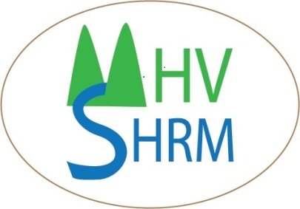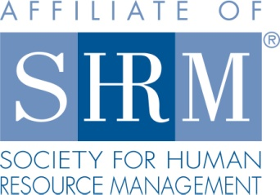
Mid-Hudson Valley
Society for Human Resource Management

April 23, 2014 Chapter Meeting

“Happy at Work……Understanding the Heart of Employee Engagement”

SPEAKER: Katherine Poehnert

Location: Harness Racing Museum
240 Main Street
Goshen, NY 12549
845-294-6330

DATE & TIME: Wednesday April 23, 2014
8:15 - 8:45 am Registration, Breakfast
8:45 – 9:15 Announcements & Introductions
9:15- 10:30 am Program

COST: $15 Chapter Member; $25 Non-Chapter Member; $7 Student

Please reserve your spot by contacting Beth Schick at info@mhvshrm.org or register online at www.mhvshrm.org

PROGRAM DESCRIPTION:
The objective of this program is to offer a unique view of the relationship between happiness, optimism and positivity and work productivity and success. Aside from the obvious, common sense belief that "when you are happy, you are more successful,” we will look at some of the neuroscientific research being done in this area, and will explore specific techniques and tools to help increase professional and personal engagement, and team effectiveness.

ABOUT THE SPEAKER: Kathy Poehnert, Principal of Ellevolution Coaching and Training, is a “Positivologist”; seeking to find opportunity in challenge, helping her clients to do the same., and sharing the foundations of Positive Psychology with groups in many organizational settings.

Kathy has over 30 years of experience training and supporting leaders in many industries, including Financial Services, Public Relations, Health Care, Marketing, Law, Banking and many more. She was an Executive coach for Deloitte, where she was a member of the Career Connections team; coaching Senior Leaders around issues related to career and personal development., often focusing on intra and inter communication skills, Emotional Intelligence, and goal-setting. She is also currently a member of the Arden Executive Coaching team; serving clients through their New York City office., and a member of the Inspirational Development Group (London);serving as a trainer for their work with Barclays Bank in the New York City area.

Kathy loves teaching and training, and was a Lead trainer for an internationally accredited Coach Training Institute for 10 years, where she facilitated discussions around values assessment and ethics., and has co-facilitated a mentor program for coaches seeking their ICF (International Coach Federation) credential for the past 6 years. She has designed and delivered hundreds of corporate and non-profit workshops/trainings and has expertise in helping leaders to hone their presentation skills as well. She was a consultant for Rutgers University, and continues to coach and train for a large non-profit in New York.

